Electric Tricycle Brushless Differential Motor 1500W 3000W
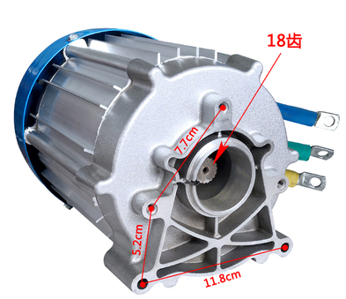
Rated Power | 1500W | 2200W | 3000W | 3000W
Rated volt | 60V/72V | 60V/72V | 60V | 72V
Rated Speed | 3200 | 60/72V | 60V | 72V
Rated Current  (A) | ≤31-28 | ≤43-39 | ≤58 | ≤58
Rated torque | 6.2n.m | 8.2n.m | 10.1n.m | 10.1n.m
Rated Effeciency | 83% | 83% | 83% | 83%
Application range | Middle&Heavy electric tricycle

